The question is that:
How have new cases and total cases developed over time in Spain?
the code to answer this question is:
40
Result discussion:
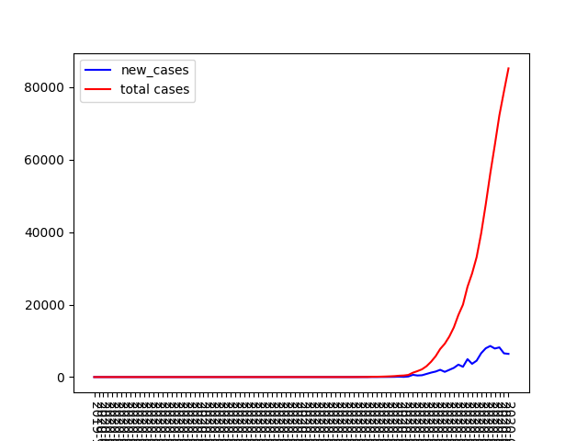
New cases and total cases in Spain
On February 26, 2022, the number of COVID-19 new cases in Spain began to increase rapidly. Previously, Spain had only two confirmed cases and no deaths. The number of new cases reached its point on March 27, when 8579 people were diagnosed with COVID-19. And the number of total death was increasing rapidly. Until March 31, 2022, the cumulative number of confirmed cases in Spain was 85195. this number continues to increase if no effective measure is taken.

